Vale of White Horse District Council Report
Abbey Fishponds, Besselsleigh Wood & Tuckmill Meadows: April – June 2026

- Actions from the previous quarter

- Brief overview for the quarter
- Spring and summer work including grassland and woodland management (controlling weeds), infrastructure repairs and habitat surveying.

- Good News!
- Tuckmill Meadows
  - Two new Dexter Steers on site at Tuckmill Meadows to continue the grazing regime.
  - 513 Southern Marsh Orchids, 200 more than last year.
  - Improved access around the reserve with 2 new boardwalks on site with a third to follow in the Autumn.
- Abbey Fishponds
  - Marsh Lousewort has established in the fen following green hay spreading in the winter. This will help reduce the dominance of rushes and improve biodiversity.

- Discussion Points
- Boardwalk update.
- New stock-pen at Tuckmill Meadows.
- Besselsleigh Wood shipping container.
- New tree officer.
- KPIs
- Improve the status of Tuckmill Meadows SSSI from Unfavourable Declining to Recovering.
  - Grazing proving successful in reducing cover of rank vegetation, however, large boom of Creeping Thistle this year, partially due to weather conditions but possibly also due to increased grazing.
    - Creeping Thistle is being tackled via repeated cutting by staff and volunteers.
- High levels of volunteer and community engagement maintained and promoted.
  - Regular communication has been maintained with the two new volunteer groups to discuss training, PPE and tool requirements.
  - New butterfly surveyors have been trained at BLW and TM and are now monitoring newly established transects.
- Site Management
  - Abbey Fishponds
    - Himalayan balsam on site pulled up to continue efforts to eradicate from site.
    - Excellent establishment of Marsh Lousewort in fen following introduction last winter.
  - Besselsleigh Wood
    - Huge effort between our volunteers and Green Appleton to clear Himalayan Balsam which is present throughout much of the wood. We also have permission from the neighbouring landowner (David Gow) to manage the plant in his woodland to the North.
  - Tuckmill Meadows
    - New bridge installed to cross the old meander at the Northern end of the site.
    - Concerted effort to scythe and clear creeping thistle ahead of it going to flower and seed.
- Graziers, subcontractors and volunteers are properly managed and monitored.
  - Worked closely with Candy to ensure Tb tests and changes of the collar batteries goes smoothly.
  - Assisted with the exchange of two female Dexters for two steers in June, including managing training on the GPS collars and provision of water in a new bowser to replace one stolen from site.
- Customer complaints dealt with according to the councils’ service standards.
  - Working with the council to resolve tree concerns with neighbours at Abbey Fishponds. Currently waiting on new tree officer to start.
- Actions
- TR to speak to BWG regarding planning application for shipping container.
- TR to add Good News! Items to the Reports.
- TR to contact Des for an update on AFP trees. Mr Crump and Mr Pratt.
- Volunteering
- Total recorded volunteer hours to date in 2026: 1256
- This includes practical work parties, volunteer wardens, wildlife surveyors.

- Wardening
Each site is visited at least once a week by an Earth Trust ranger as well as additional visits from volunteer wardens. During each visit, our wardens check all site furniture, litter pick, check for any safety concerns and record any interesting wildlife they come across. All of this is then reported back to the Earth Trust.
Location | Date | Hazard | Priority | Actioned
Abbey Fishponds | 14/04/2026 | Dumped bike frame on site | Low | Removed same day.
Besselsleigh Wood | 15/04/2026 | Vegetation starting to overhang footpath | Low | Cut back same day.
Tuckmill Meadows | 22/04/2026 | One of the gate posts in the stock pen is rotten | Low | Recorded and put in future workplan to repair.
Besselsleigh Wood | 11/04/2026 | A tree from Collier’s copse had snapped and was partially blocking part of the footpath | Medium | Path was cleared back to the boundary.
Tuckmill Meadows | 08/06/2026 | Mesh on the new boardwalk had come loose and needed stapling down | Medium | Mesh was stapled back into place.
Abbey Fishponds | 22/06/2026 | An ash tree had snapped and blocked the path towards the Radley Road entrance | Medium | Was reported to council tree team and promptly cleared.

- Grazing / hay cutting
- Tuckmill: TB tests 18.05 & 21.05
- Tuckmill: two new steers introduced onto site and two females removed 18.06.26

- Events
- No events run during this time.

- Survey work
- Butterfly transects underway on all sites with Silver Washed Fritillary and Purple Emperor recorded at Besselsleigh Wood.
- Tuckmill: orchid count recorded 513 Southern Marsh Orchids. Over 200 more than recorded last year.
- Council habitat assessment undertaken at Tuckmill Meadows in June, awaiting results.

- Management tasks
Location | Habitat Management | Who
Abbey Fishponds | The northern fen was scythed to keep on top of regrowth of the reeds. This, along with the marsh lousewort, should help to suppress the reeds. | Thursday Group
Abbey Fishponds | Four new ponds were dug in the northern and southern fen | Thursday Group
Abbey Fishponds | The kissing gate at the Radley Road entrance was repaired | Thursday Group
Abbey Fishponds | Grassland areas were scythed to keep on top of growth | Thursday Group
Abbey Fishponds | Himalayan balsam was pulled in the northern fen | Thursday Group
Abbey Fishponds | Footpaths were mown | Council
Besselsleigh Wood | One of the old bridges was removed and replaced with a new one as it had become rotten and dangerous | Wednesday Group
Besselsleigh Wood | A tree had come down across a footpath. This was processed and stacked up away from the path | Wednesday Group
Besselsleigh Wood | Pulled Himalayan balsam | Thursday Group
Tuckmill Meadows | Installation of the new boardwalk that runs along the eastern perimeter. | Contractors
Tuckmill Meadows | Removal of blackthorn stumps in the stock pen area | Wednesday Group
Tuckmill Meadows | Installation of steps either end of the boardwalk | Tuckmill Group
Tuckmill Meadows | Thistles were pulled and nettles cut back on the chalk grassland bank | Tuckmill Group
Tuckmill Meadows | Installation of a bridge at the bottom of the reserve | Contractors
Tuckmill Meadows | Overhanging vegetation was cleared back from the boardwalk, so members of the public don’t have to duck to avoid it | Rangers
Tuckmill Meadows | Low hanging willow limbs were removed above the footpath at the bottom of the reserve | Rangers
Tuckmill Meadows | Steps were installed at either end of the newest footbridge at the bottom of the reserve | Monday Group
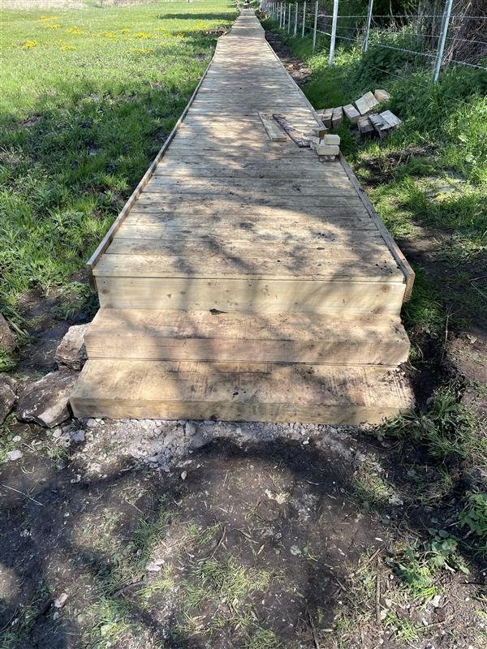
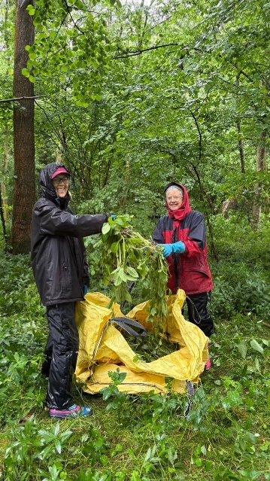
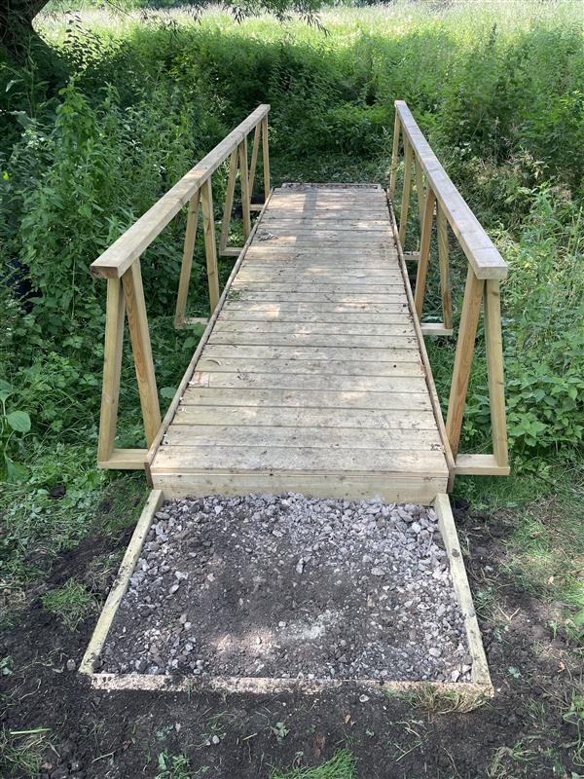
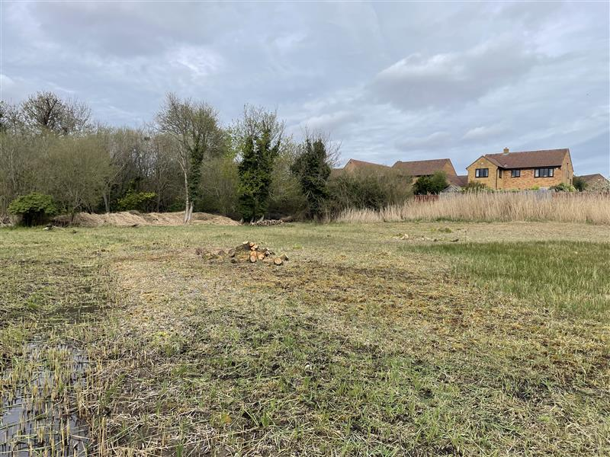
From top-left:
- New footbridge at Tuckmill Meadows.
- Himalayan Balsam pulling at Besselsleigh Wood.
- New Boardwalk at Tuckmill Meadows.
- Reeds cut at Abbey Fishponds to promote Marsh Lousewort growth.

