South Oxfordshire District Council Report
Wallingford Castle Meadows, Riverside Meadows & Mowbray Fields: April – June 2026

- Actions from previous quarter
- TS to chase up payment to Castle Water.
- TS to follow up with legal team regarding narrowboat.
- TS to follow up with Grounds Maintenance team regarding Mowbray Security.
- Community Action contact regarding sign and bug hotel at Mowbray.
- Brief overview for the quarter
- Spring and summer work including grassland management (controlling weeds), restoration of flood-damaged infrastructure and installation of new fencing at Riverside Meadows.
- Hay cut and grazing plan for Wallingford sites.
- Orchid count at Mowbray Fields.

- Good News!
- Wallingford Castle Meadows has been successful in achieving the Green Flag Award.

- Discussion Points
- Riverside Meadow Boats still present, being escalated to local councillor.
- Cycling without age access to WCM.
- WCM bench replacement.
- People Counters.
- Management Plan update.
- KPIs
- High levels of volunteer and community engagement maintained and promoted.
  - Saturday work party at WCM continues to expand, now attended by up to 15 local volunteers.
  - Young Ranger team established, building experience for DoE students.
  - Green Flag and Green Heritage awarded at Wallingford Castle Meadows for 2026.
- Monitor and report on visitor numbers and satisfaction at Wallingford Castle Meadows.
  - Ongoing work to develop survey which can be completed online and advertised via a QR code.
  - No visitor satisfaction surveys undertaken to date.
- Site Management
  - Wallingford Castle Meadows
    - Ragwort, thistle and hemlock control.
    - Infrastructure maintenance including replacement of the stock pen gates and fence repair.
  - Riverside Meadows
    - Infrastructure maintenance including fence repair and excavation of drainage ditch.
  - Mowbray Fields
    - Infrastructure maintenance including boardwalk repair and bench maintenance.
- Provisions of Higher-Level Stewardship are undertaken.
  - Grazing at Wallingford Castle Meadows undertaken as laid out in HLS agreement.
  - Consent agreed for earlier hay cut in late June to support floodplain meadow management.
- Graziers, subcontractors and volunteers are properly managed and monitored.
  - All volunteer work parties are supervised by trained volunteer leaders and have a staff lead to support them whenever required.
  - Grazier Andrew Townsend works closely with ET staff to time grazing, hay cutting and to resolve other ad-hoc situations.
    - This included applying for a derogation for an earlier hay cut this year to reduce nutrient loads within the floodplain.
- Customer complaints dealt with according to the councils’ service standards.
  - Ongoing interactions with resident of narrow boat at Riverside Meadows. To be escalated by SODC legal team.
- Actions
- TS to follow up with James Barlow regarding narrowboat at RM.
- TS to follow up with AB regarding Cycling without Age, holding email.
- Volunteering
- Total recorded volunteer hours to date in 2026: 242
  - This includes practical work parties, volunteer wardens, wildlife surveyors.

- Wardening
Each site is visited at least once a week by an Earth Trust ranger as well as additional visits from volunteer wardens. During each visit, our wardens check all site furniture, litter pick, check for any safety concerns and record any interesting wildlife they come across. All of this is then reported back to the Earth Trust.
Location | Date | Hazard | Priority | Actioned
Wallingford Castle Meadows | 13/04/2026 | Rotten post & rail fence at the entrance to Kings Meadow | Low | Repaired on 13/04/2026
Mowbray Fields | 01/05/2026 | Damage to circular boardwalk | Low | Recorded and put into future work plan
Mowbray Fields | 23/04/2026 | Small, snapped willow branch | Low | Branch removed
Riverside Meadows | 05/05/2026 | Wobbly people counter post | Low | Recorded and put into future work plan
Wallingford Castle Meadows | 25/06/2026 | One of the steps at the dipping pond is rotten | Medium | Recorded and put into future work plan

- Grazing / hay cutting
- Wallingford Castle Meadows: Kings Meadow & Queens Arbor cut & baled 12/06/2026
- Riverside Meadows: Field A & C cut and baled 12/06/2026
  - Field B flailed and left due to litter.
- Events
- No events have been run during this time.

- Survey work
- Mowbray orchid count (15/06/2026) recorded 316 orchids, an increase from recent years but still below 2020 when 700+ were recorded. This decline was likely due to a lapse in meadow cutting but is increasing again.

- Management tasks
Location | Habitat Management | Who
Wallingford Castle Meadows | The post & rail fence in Kings meadow had become rotten at the base and needed replacing. | Monday Group
Wallingford Castle Meadows | The barbed wire at the cemetery lane entrance was replaced as the old stretch was slack & broken. | Saturday Group
Wallingford Castle Meadows | Repaired the barbed wire around the moat where it had been cut to allow access onto the castle mound. | Saturday Group
Wallingford Castle Meadows | Scythed along the woodland path to keep it accessible. | Saturday Group
Wallingford Castle Meadows | Clumps of wildflowers were planted in Kings Meadow to try and improve the diversity. | Saturday Group
Wallingford Castle Meadows | The gate on the roadside of the stock pen was replaced as the previous one was completely broken. | Wednesday Group
Wallingford Castle Meadows | The remaining wildflowers were planted in Kings Meadow. | Wednesday Group
Wallingford Castle Meadows | The people counter posts were removed to allow easier access for tractor and baler into Kings Meadow. | Friday Group
Wallingford Castle Meadows | The second gate on the stock pen was replaced with a new hanging post also installed. | Friday Group
Wallingford Castle Meadows | Large areas of hemlock were removed. | Friday & Saturday Group
Riverside Meadows | The barbed wire in field C needed re-tensioned as it had become slack over time. | Monday Group
Riverside Meadows | Clearance of drainage ditch and knocking back of scrub in medieval channel. | Saturday Group
Mowbray Fields | Repaired the broken posts on the bridge. | Monday Group
Mowbray Fields | Relocated bug hotel as it had been placed in the middle of the meadow. | Monday Group

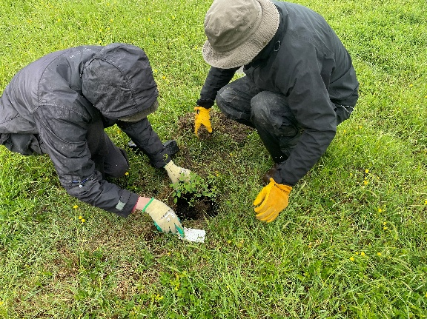
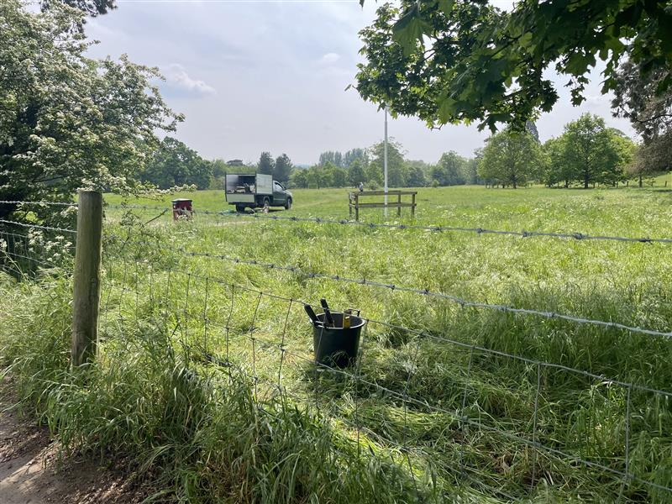
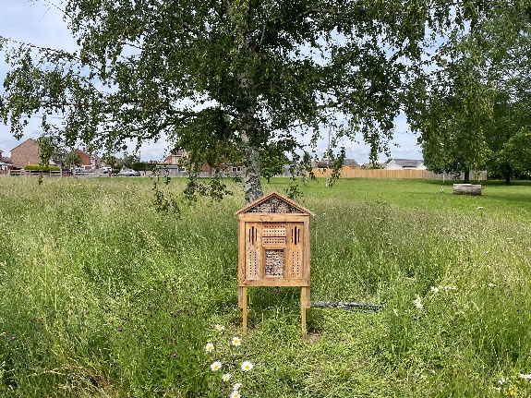

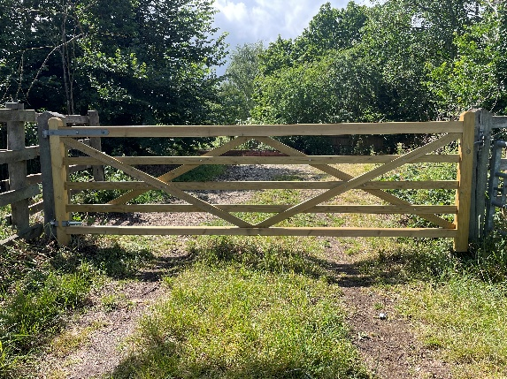

From top-left:
- Fence repair at Wallingford Castle Meadows.
- Relocated bug hotel at Mowbray Fields.
- Meadow planting at Wallingford Castle Meadows.
- New gates at Wallingford Castle Meadows.

