Vale of White Horse District Council Report
Abbey Fishponds, Besselsleigh Wood & Tuckmill Meadows: October – December 2025

Brief overview for the quarter
- Finishing up of summer work including clearing footpaths and infrastructure, installation of people counters and repairs to gates and fences.
- Winter work including tree and scrub clearance and coppicing work.
Wardening
Each site is visited at least once a week by an Earth Trust ranger as well as additional visits from volunteer wardens. During each visit, our wardens check all site furniture, litter pick, check for any safety concerns and record any interesting wildlife they come across. All of this is then reported back to the Earth Trust.
Location | Date | Hazard | Priority | Actioned
Tuckmill Meadows | 28/10/2025 | The footbridge nearest the car park was collapsing and unsafe to walk on | Medium | Signage was put up advising people to stay off it until it is repaired
Abbey Fishponds | 28/10/2025 | Willow overhanging footpath | Medium | Tree was removed on the next visit to site
Abbey Fishponds | 06/11/2025 | Garden waste fly tipping near the Radley Road entrance | Low | Reported to Vale council which was later removed
Tuckmill Meadows | 21/11/2025 | Some loose kickboards on the boardwalk that need nailing back in | Low | Nailed back in place on next visit
Besselsleigh Woods | 11/12/2025 | Large oak limb had come down next to a permissive footpath | Medium | Limb was processed and removed from footpath

Total number of volunteer visits & to each site:
Abbey Fishponds: 5
Besselsleigh Wood: 47
Tuckmill Meadows: *we are recruiting volunteers locally to warden, we have 3 ‘informal’ wardens but weekly visits are undertaken by staff.

Management tasks
Location | Habitat Management | Who
Abbey Fishponds | The reedbed in the northern fen was cleared in preparation for sowing of green hay | Thursday Group
Abbey Fishponds | The sowing of marsh lousewort took place in the fen to help target the regrowth of the reeds | Thursday Group
Abbey Fishponds | A large willow had snapped and was overhanging the footpath, so this was felled before it got worse | Rangers
Abbey Fishponds | Put woodchip down on the path from Hadland road | Thursday Group
Abbey Fishponds | Felled willow trees in northern fen | Wednesday Group
Abbey Fishponds | Started removing brash in northern fen to create dead hedges and log piles | Thursday Group
Besselsleigh Wood | A large oak had fallen near a footpath, the brash and debris was cleared from the path, and a deadwood habitat was created around the tree | Besselsleigh Group
Besselsleigh Wood | Installed way markers around the site to clearly identify permissive footpaths and PROWs | Besselsleigh Group
Tuckmill Meadows | People counter posts were installed at both entrances to the site to hopefully provide us with a better understanding of how the site is used | Wednesday Group
Tuckmill Meadows | A large patch of brambles next to the stream has started to be cut back to allow more light in | Tuckmill Workparty
Tuckmill Meadows | The old bridge across Ratcombe stream was removed and replaced as it was starting to collapse | Wednesday Group

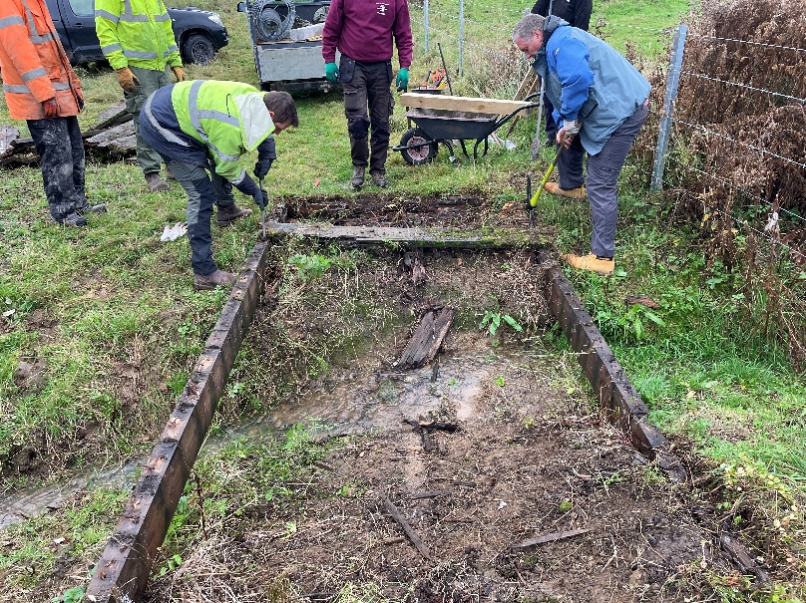
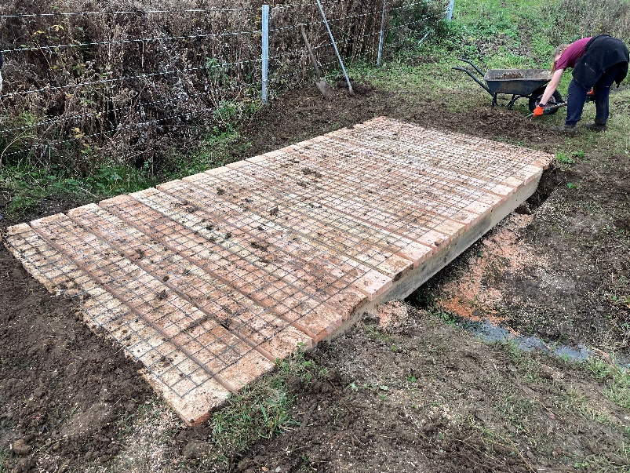
The bridge at Tuckmill Meadows was replaced with timber from the ET farm.

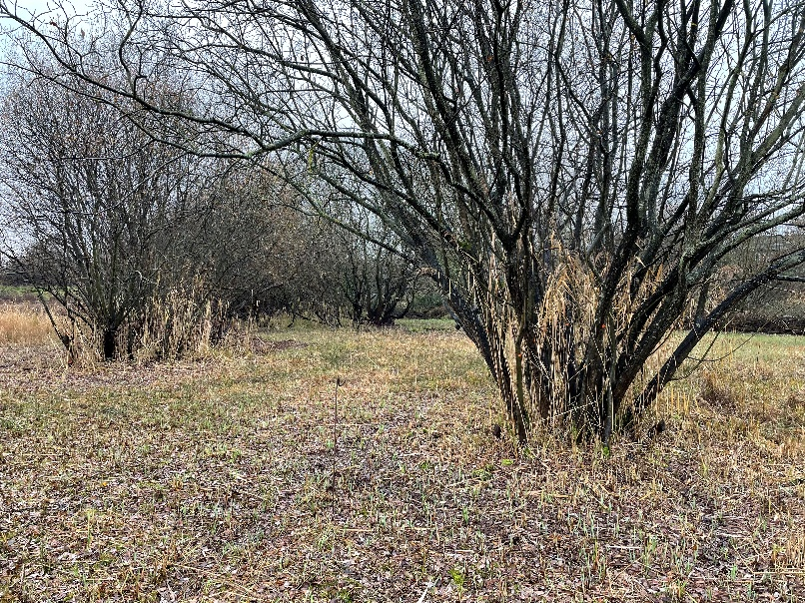
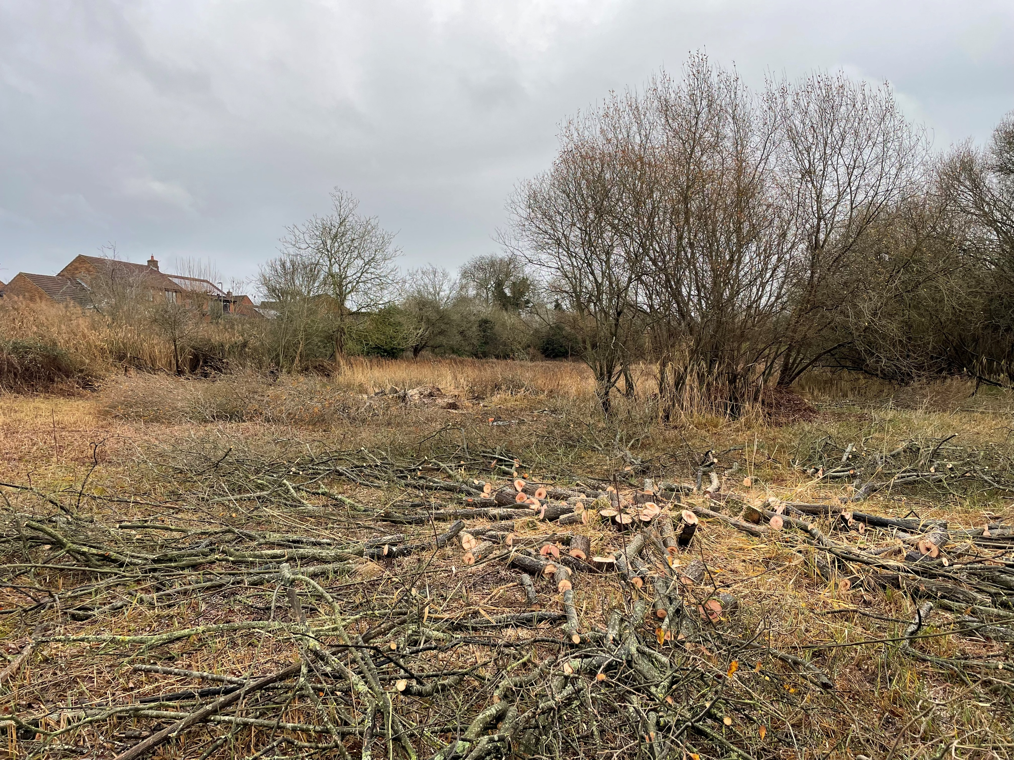
Willow trees in the northern fen at Abbey Fishponds were felled, with brash and logs being stacked to create habitat on site.

