Vale of White Horse District Council Report
Abbey Fishponds, Besselsleigh Wood & Tuckmill Meadows: July – September 2025

Brief overview for the quarter
- Cows introduced to Tuckmill Meadows, Site of Special Scientific Interest (SSSI).
- Summer work across the reserves including gate and fence repair and weed management.
- Beginning the restoration work of the Soligenous Fen at Abbey Fishponds by cutting the reed bed in preparation for sowing of green hay from Hinksey Heights.
Wardening
Each site is visited at least once a week by an Earth Trust ranger as well as additional visits from volunteer wardens. During each visit, our wardens check all site furniture, litter pick, check for any safety concerns and record any interesting wildlife they come across. All of this is then reported back to the Earth Trust. Here are some of the concerns raised over the last quarter.
Location | Date | Hazard | Priority | Actioned
Besselsleigh | 03/07/25 | Bees swarming around the base of the tree, looking like the start of a hive | Medium | Signage put up to warn public
Besselsleigh | 03/07/25 | Small tree has fallen across the track | High | Tree was cleared to keep path open for public
Tuckmill Meadows | 07/07/25 | A couple of sides on the boardwalk have come loose, just need nailing back in place | Low | Boards nailed back in place
Abbey Fishponds | 20/08/2025 | There were a couple of reports that a hornet’s nest had been located next to the bridge. | Medium | Signage was erected at all entrances warning the public and the nest site was monitored

Total number of volunteer visits & to each site:
Abbey Fishponds: 4
Besselsleigh Wood: 15
Tuckmill Meadows: *we are recruiting volunteers locally to warden, we have 3 ‘informal’ wardens, but weekly visits are undertaken by staff.

Management tasks
Location | Management | Who
Abbey Fishponds | Reeds either side of the footpath were cut back as they were starting to encroach | Thursday Group
Abbey Fishponds | Overhanging vegetation was cut back on the perimeter path | Thursday Group
Abbey Fishponds | The grass on and around daisy bank was cut | Thursday Group
Abbey Fishponds | Another set of posts were installed for people counters to try and understand the foot traffic and how the site is used | Monday Group
Abbey Fishponds | The perimeter footpaths had all vegetation cut back to make it easier for people to walk through without getting stung/cut | Thursday Group
Abbey Fishponds | Areas of grassland habitat were scythed | Thursday Group
Abbey Fishponds | The northern reed bed was cut in preparation for marsh lousewort casting | Thursday Group
Abbey Fishponds | Woodchip was put down on areas of the footpath in preparation for wetter weather, making the site more accessible for walkers | Thursday Group
Besselsleigh Wood | Himalayan balsam pulling to control spread. | Thursday Group
Besselsleigh Wood | The posts for people counters were installed at two entrances to the site to try and understand the foot traffic and how the site is used | Monday Group
Besselsleigh Wood | Footpath restoration around the woods to make it accessible all year round | Besselsleigh Group
Tuckmill Meadows | The rotten rails on the stock pen were removed and replaced with new ones in preparation for cattle arriving on site | Wednesday Group
Tuckmill Meadows | The notice board was put back up just inside the pedestrian gate | Wednesday Group
Tuckmill Meadows | All pallets that were being used to walk across have been removed to avoid cattle injuring themselves | Wednesday Group
Tuckmill Meadows | A new pond was dug next to the boardwalk | Friends of Tuckmill
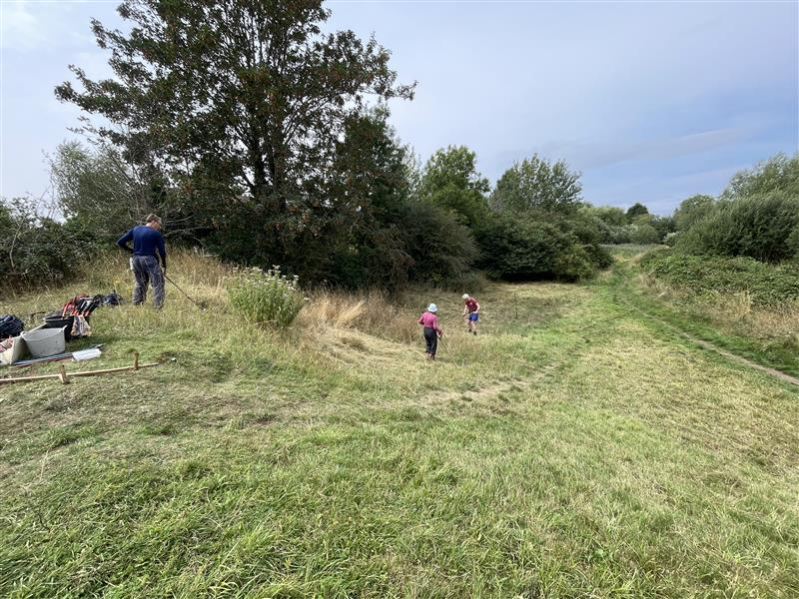
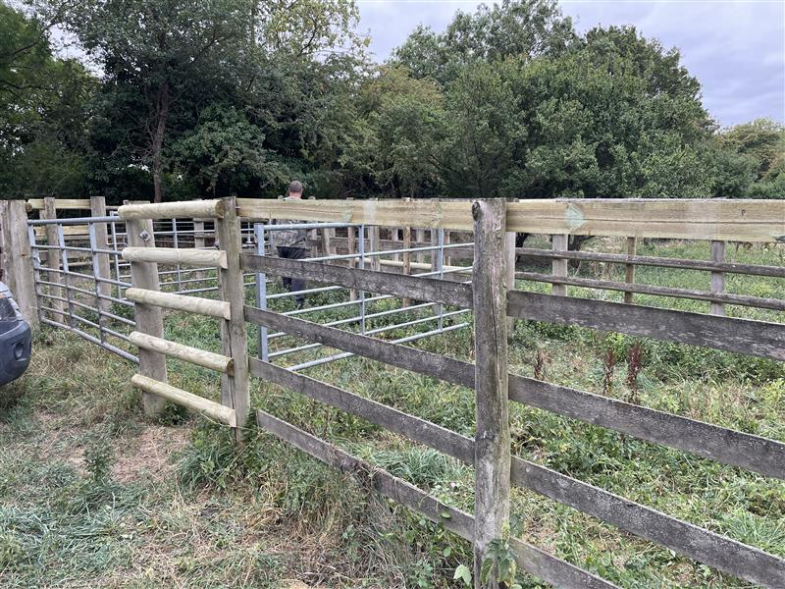
Abbey Fishponds – Grass cutting on daisy bank and adjacent grassland
Tuckmill Meadows – Repairing the stock pen in preparation for cattle being introduced onto site

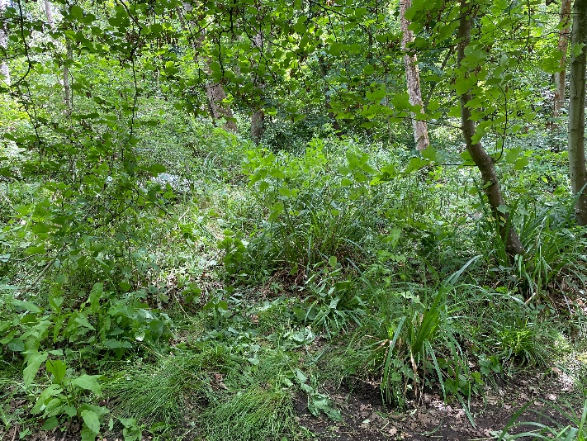
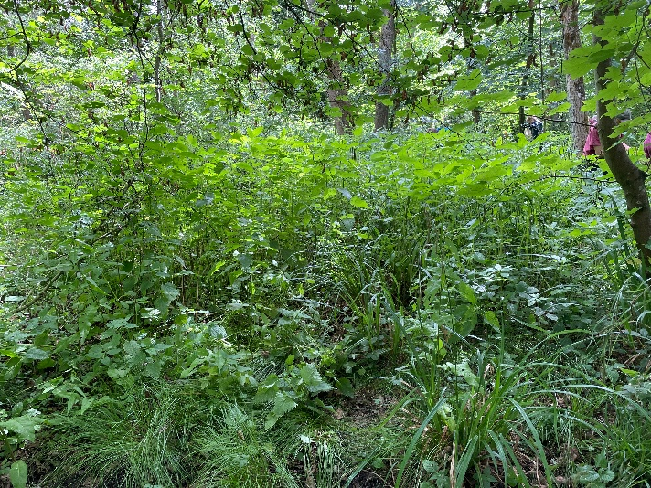
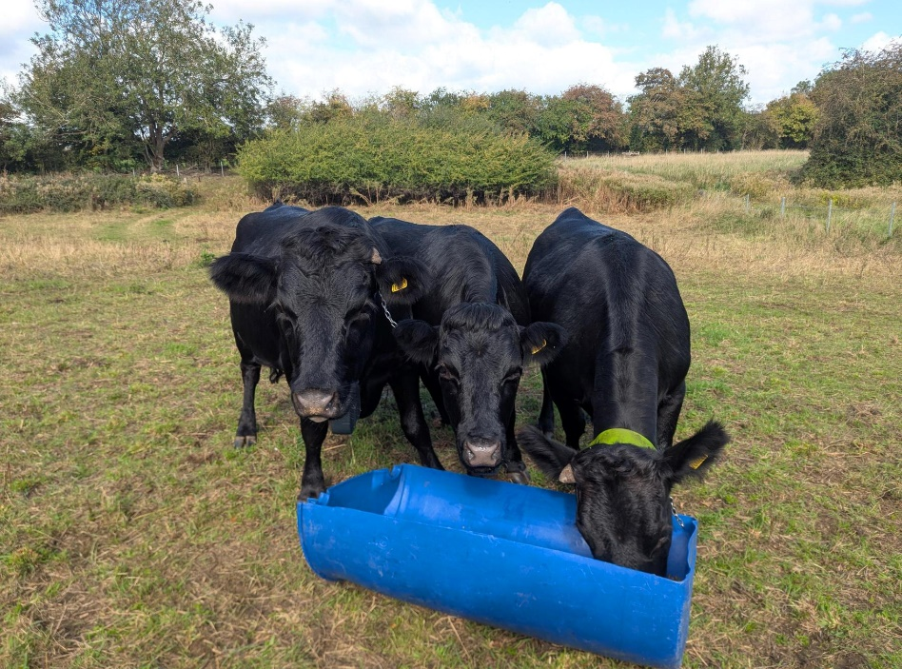
Besselsleigh Wood – Before and after Himalayan Balsam Pulling.
The three Dexters at Tuckmill Meadows.

