Task Risk Assessment
Task: Scything Date: 14/08/2024
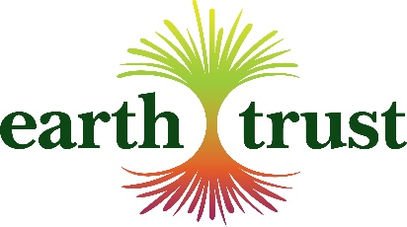

This risk assessment will be updated annually following a review or whenever further risks or control measures are identified.

Prior to the task taking place the task leader will assess the task and give a risk assessment briefing to all staff and volunteers to include use of tools, site conditions, manual handling etc.

PPE required to carry out this task: | Appropriate footwear for terrain; trousers/long sleeved tops as required depending on work site.
Training required to carry out this task: | In-house training
Can this task be carried out by a lone worker: | Yes
Minimum level of first aid required to carry out this task:  (EFAW, FAAW, FAAW+F) | Emergency First Aid at Work 1:50

HAZARD  Potential Harm | PEOPLE AT RISK | EXISTING CONTROL METHODS  Staff and volunteers instructed or trained to: | FURTHER ACTIONS REQUIRED | CORRECTIVE ACTIONS
 |  |  |  | WHO | WHEN | COMPLETED
Loading, transporting and unloading of tools:  Cuts/strain injury | Staff & volunteers | Bag, wrap, carry in container or cover blade with plastic guard when being transported.  When not in use scythes must be left flat on the ground, visible, with the sharp edge facing down.
Untrained operator:  Cuts, strain injury & injury to self or others | Staff & volunteers | All operators to have attended Earth Trust Training Day and competency assessment or equivalent.  All operators to maintain a safe working distance of twice the length of the scythe.
Back strain:  Muscular injury | Staff & volunteers | Work party leader to ensure scythe operators take breaks as required.
Adverse effects of contact with harmful flora: e.g. Rash, allergy, photosensitivity | Staff & volunteers | Assess work site vegetation prior to cutting and take appropriate precautions.  Do not cut material if risk of injury cannot be reduced. | Wear additional PPE or cover skin as required when cutting plants with poisonous/irritating sap, stings or thorns e.g. hogweed, nettles.
Stings from bees, wasps or hornets:  Possible allergic reactions can cause discomfort and in severe cases anaphylactic shock | Staff & volunteers | Check work area prior to starting and be aware of any nearby nests  If operator has a known severe allergy, i.e. anaphylaxis that will reduce ability to breathe rapidly, operator cannot scythe. | Check work area prior to starting for any nests close by.
Uneven surfaces:  Slips, trips, or loss of balance | Staff & volunteers | Avoid cutting on dangerous slopes, unless can ensure safe footing.  Wear sturdy footwear which offers good grip.  Adopt correct posture and movement when mowing.
The task covered by this risk assessment should only be carried out by a member of staff or volunteer who is trained and authorised to do so. If you have any medical condition which might increase the likelihood of an accident or injury resulting from carrying out this task then you must discuss this with and be authorised by your line manager, before you attempt the task.

 | Assessment date | Assessor | Position
Initial assessment undertaken on | 14/08/2024 | Tim Read | Countryside Manager
Review 1 completed: | 11/08/2025 | Tim Read | Countryside Manager
Review 2 completed:
Review 3 completed:
Review 4 completed:
Review 5 completed:

