South Oxfordshire District Council Report
Wallingford Castle Meadows, Riverside Meadows & Mowbray Fields: October - December 2025
Brief overview of the quarter
- Finishing up of summer work including clearing footpaths and infrastructure, installation of people counters and repairs to gates and fences.
- Winter work including tree and scrub clearance, coppicing and drainage works.
Wardening
Each site is visited at least once a week by an Earth Trust ranger as well as additional visits from volunteer wardens. During each visit, our wardens check all site furniture, litter pick, check for any safety concerns and record any interesting wildlife they come across. All of this is then reported back to the Earth Trust. Here are some of the concerns raised over the last quarter.
Location | Date | Hazard | Priority | Actioned
Riverside Meadows | 22/10/2025 | Reports of a tent in field C that had been abandoned | Low | Tent and belongings inside were removed
Mowbray Fields | 01/11/2025 | Loose boards on the central boardwalk | Low | Boards and kickboard were nailed back into place
Riverside Meadows | 09/12/2025 | Broken glass was reported around the pillbox | Low | Rubbish was picked up and removed from the site
Mowbray Fields | 29/12/2025 | A bike was dumped in the fill pond | Low | Bike removed in the new year
Riverside Meadows | 22/10/2025 | Reports of a tent in field C that had been abandoned | Low | Tent and belongings inside were removed

Total number of volunteer visits & to each site:
Wallingford Castle Meadows: 13
Riverside Meadows: 11
Mowbray Fields: 8

Management tasks
Location | Habitat Management | Who
Wallingford Castle Meadows | A tree had fallen over the fence into kings’ meadow. This was cleared and the fence was repaired | Wednesday Group
Wallingford Castle Meadows | A gate in the stock pen had rotted out and needed replacing | Wednesday Group
Wallingford Castle Meadows | The vehicle gate from the road onto the reserve was adjusted to make it easier to open | Wednesday Group
Wallingford Castle Meadows | Two people counter posts were added in the gateway between castle meadow and kings’ meadow | Wednesday Group
Wallingford Castle Meadows | The leaking trough in kings’ meadow was fixed | Wednesday Group
Wallingford Castle Meadows | The bench next to the dipping pond was broken so the feet were removed and replaced with new ones | Saturday Group
Wallingford Castle Meadows | A small section of the hazel was coppiced | Saturday Group
Riverside Meadows | Scything of rank vegetation in Field A to prevent the meadow from shrinking in size | Saturday Group
Riverside Meadows | Cleared brambles around interpretation board | Saturday Group
Riverside Meadows | Cut back the vegetation along the stream into field B | Saturday Group
Riverside Meadows | De-silted and dug out drainage ditch in field A | Saturday Group
Mowbray Fields | Finished cutting the wet meadow | Friday Group
Mowbray Fields | Finished cutting the willow in the rotational coppice area | Friday Group
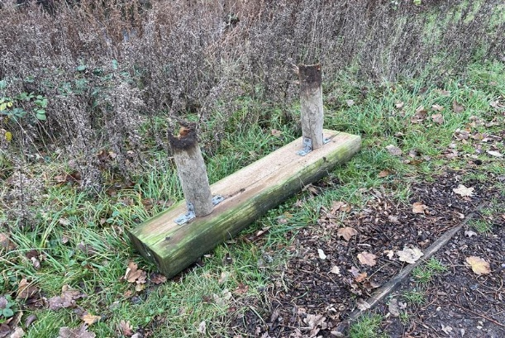
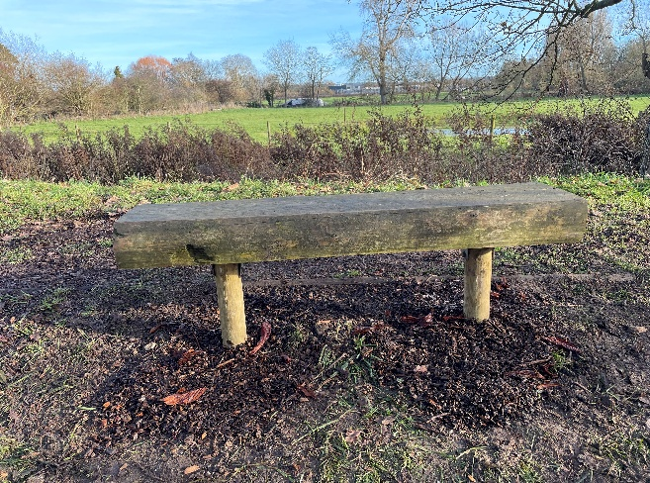
The bench at the dipping pond at Wallingford Castle Meadows was replaced after it had become unsafe to sit on.

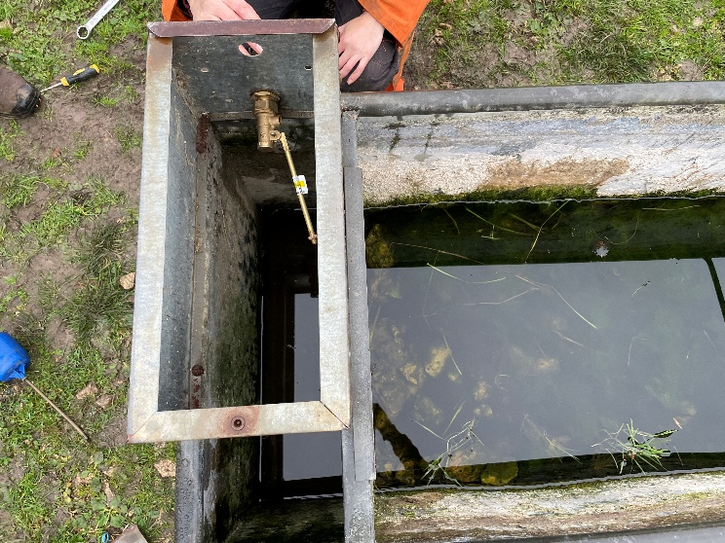
The leaking trough in Kings Meadow was repaired.

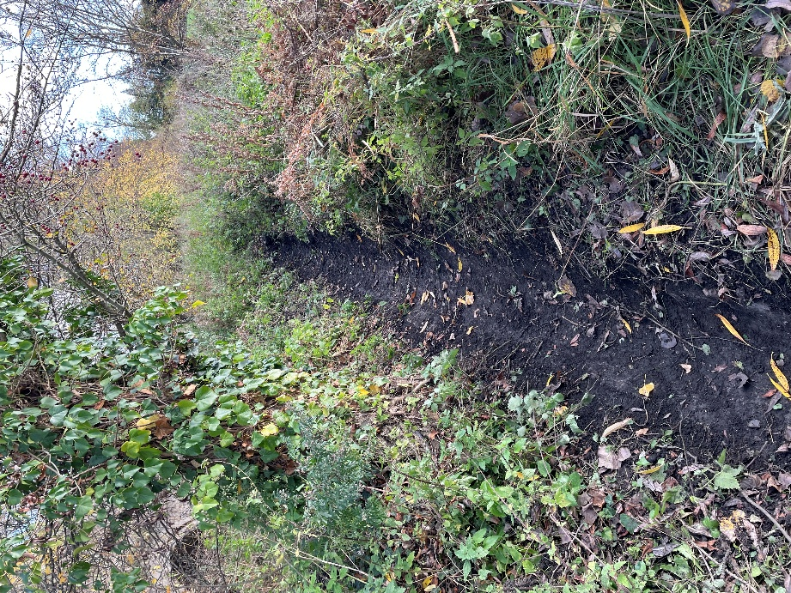
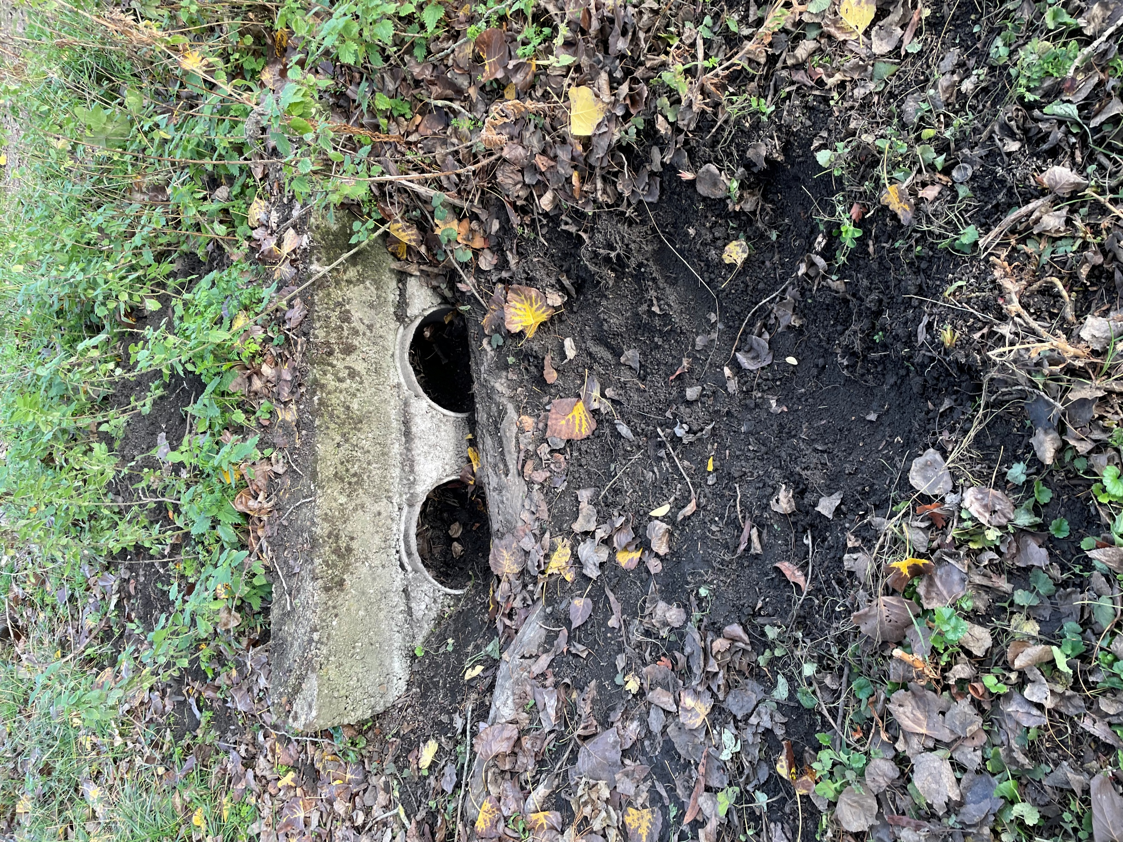
The ditches at Riverside Meadows require periodic clearing to avoid a build-up of debris.

