South Oxfordshire District Council Report
Wallingford Castle Meadows, Riverside Meadows & Mowbray Fields: July – September 2025
Brief overview of the quarter
- Summer work across the reserves including gate and fence repair, weed management and mowing of wildflower areas at the end of the season.
- Some challenges including travellers moving into Mowbray Fields, removal of large windthrow willow from floodplain at WCM and responding to online criticism of site management.
Wardening
Each site is visited at least once a week by an Earth Trust ranger as well as additional visits from volunteer wardens. During each visit, our wardens check all site furniture, litter pick, check for any safety concerns and record any interesting wildlife they come across. All of this is then reported back to the Earth Trust. Here are some of the concerns raised over the last quarter.
Location | Date | Hazard | Priority | Actioned
Mowbray Fields | 01/07/2025 | A leather sofa was fly tipped in the wooded area | Low | Liaised with the council for it to be removed 03/07/25.
Riverside Meadows | 05/08/2025 | A large willow tree on the outskirts of field C had snapped and fallen on the edge of the Thames | Low | An email was sent to the tree safety officer on 06/08/25 asking to assess.
Mowbray Fields | 10/08/2025 | A den was being made using orange barriers, planks of wood and broken tree limbs in the woods | Low | All materials were removed to try and deter the den from being rebuilt.
Riverside Meadows | 28/08/2025 | A tree has fallen between fields A and B across the ditch. This isn’t near any footpaths and poses no immediate risk. | Low | Put into the future work plan to be removed with the next weekend work party.
Mowbray Fields | 10/09/2025 | Travellers moved onto site | Medium | Police and council worked to move them on, with them eventually leaving. A big clear up took place on 16/09/2025.
Total number of volunteer visits & to each site:
Wallingford Castle Meadows: 23
Riverside Meadows: 12
Mowbray Fields: 13

Management tasks
Location | Management | Who
Wallingford Castle Meadows | Brash and small logs removed from Queen’s Arbor | Wednesday Group
Wallingford Castle Meadows | Remaining brash in upper meadow was chipped | Wednesday Group
Wallingford Castle Meadows | Standing deadwood in Queens Arbor was felled as it posed a health and safety concern | Council
Wallingford Castle Meadows | Ragwort was pulled from the scheduled monument | Saturday Group
Wallingford Castle Meadows | Sections of the post and rail around the stock pen were rotten so these were removed and replaced | Monday Group
Wallingford Castle Meadows | The fallen willow and felled deadwood from Queen’s Arbor were removed and placed into Castle Meadow to create deadwood habitats and natural seating areas for the public to enjoy | Ranger & Contractors
Wallingford Castle Meadows | Ragwort was pulled from around the scheduled monument | Friday Group
Wallingford Castle Meadows | Ragwort was pulled from around the scheduled monument | Wallingford Green Gym
Wallingford Castle Meadows | A section of fence next to the dipping pond had fallen over so this was removed and replaced to ensure the site remained stock proof | Saturday Group
Wallingford Castle Meadows | Overhanging vegetation on the track through the wooded area was cleared to make sure vehicles could still get in easily | Saturday Group
Wallingford Castle Meadows | Cleared scrub off fence line in Kings Meadow | Saturday Group
Wallingford Castle Meadows | Four fence posts were replaced in Queens Arbor | Saturday Group
Mowbray Fields | Vegetation was cleared from in and around the fill pond to prevent the area from scrubbing up as this is a great patch for orchids | Friday Group
Mowbray Fields | The trees in the wildflower meadow were brushcut around, in preparation for the tractor to cut and collect the rest of the meadow | Friday Group
Mowbray Fields | Scythed and cleared scrub from fill pond to access and start cutting the wet meadow | Friday Group
Mowbray Fields | Started work on rotational willow coppice area | Friday Group

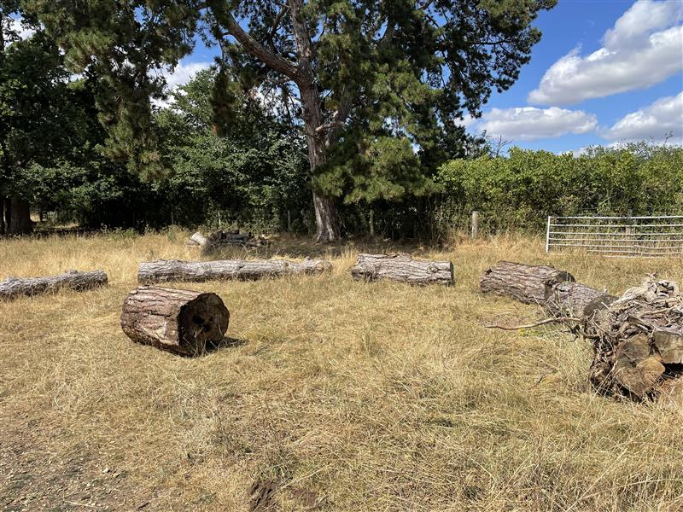
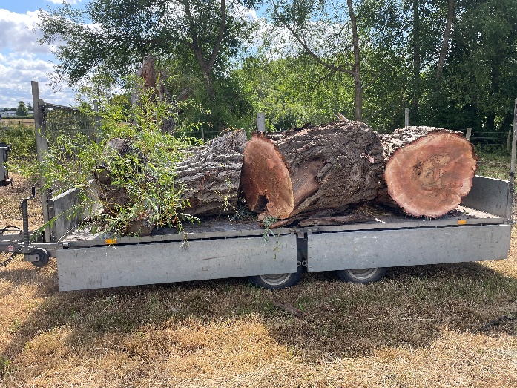
Wallingford Castle Meadows – Large logs removed from Queens Arbor into Castle Meadows for deadwood habitat / seating areas.

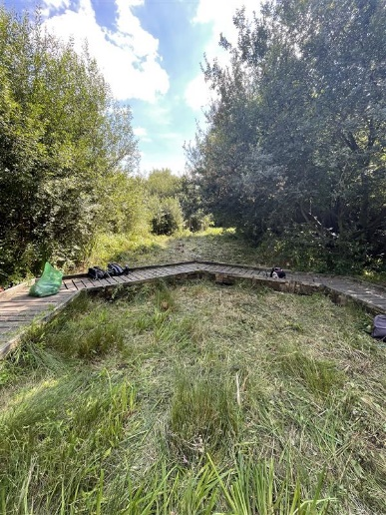
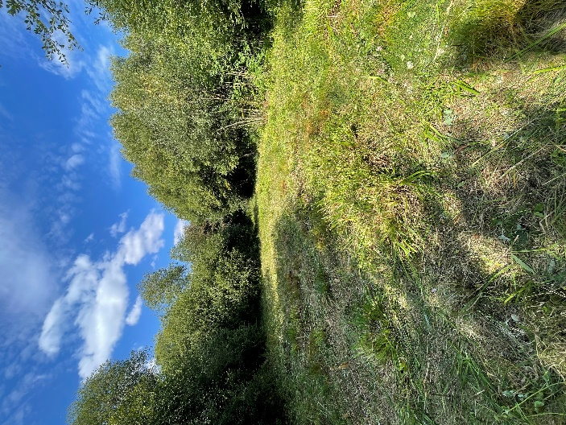
Mowbray Fields – cutting vegetation around the boardwalk and mowing the wet meadow.

