 | RISK ASSESSMENT | RA No. | EE1

Use of Outdoor Spaces – Earth Trust Centre by Environmental Education
Assessment date | 28/07/2025 | Review date  (within 1 years)
Work area | Clumps, Little Wittenham Woods, Farm, Arboretum, River Thames
Reason for Assessment: Annual Review
Assessor: Stuart Ritchie (Environmental Education Manager)

Part 1 – Hazard Identification and Method Statement
- General Description of the Work Area | Associated Hazards
Mixed outdoor landscape including:  - The Wittenham Clumps  - Little Wittenham Wood  - Broad Arboretum  - Wildflower Meadows  - The Rookery Woodland  - Days Lock on the Thames  - Earth Trust farm  - Hurst Water Meadows, Dorchester | - Falling into the Thames  - Slips, Trips and Falls  - Stings, Allergies and Ticks  - Contact with farm animals  - Falling branches  - Bacteria from soil, water and compost  - Ingestion of non-edible plants  - Burns and scalds  - Starting wildfire  - Discarded items  - Weather associated hazards  - Members of the public  - Lost children  - Drowning or water borne diseases
- Plant, Equipment and Vehicles | Associated Hazards
- Tractor + Farm vehicles  - Hand Tools  - Nets and survey equipment | - Collision with vehicle  - Cuts or crush injuries  - Diseases from soil or water

 | RISK ASSESSMENT | RA No.

- Method Statement  Description of how the work will be done and by whom | Associated Hazards
Guided working with organised groups of children and young people (preschool to 18Y/O) and adults in the outdoor spaces with appropriate adult: child ratios in the outdoor landscape on the Earth Trust farm, Wittenham Clumps, River Thames and Hurst Water Meadows with appropriate adult: child ratios. All tutors outdoor first aid trained. Child supervisors includes tutors, education volunteers, teachers, parents and TA’s. Safety briefing issued at the beginning of each session: Site orientation, uneven surfaces, staying together, setting boundaries.

Assessor signature/s (all involved should sign):
Stuart Ritchie (Environmental Education Manager)

Signed off by:

Colin Shone (Centre Operations Manager)

 | RISK ASSESSMENT | RA No.

Part 2 – Detailed Assessment of Risks
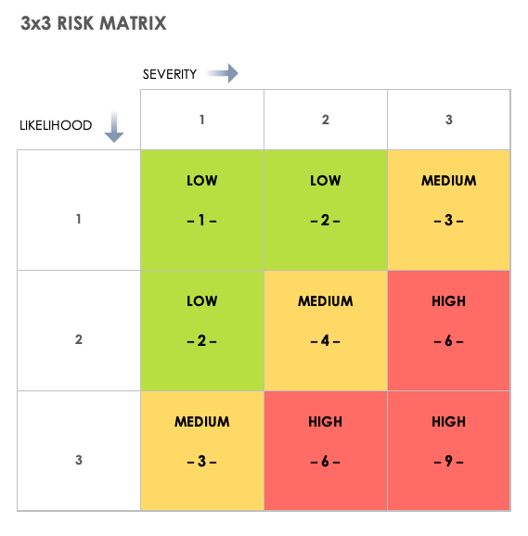

Hazard  Potential harm and how caused | Persons likely to be affected | Existing control measures | Risk Rating before further measures | Further action required or ongoing measures to control risk | Risk Rating after measures | Corrective Action
Hazard  Potential harm and how caused | Persons likely to be affected | Existing control measures | Likelihood x severity | Further action required or ongoing measures to control risk | Likelihood x severity | Who | When | Done
Falling into the river Thames  - Severe (death)  - Unsafe behaviour, Slipping or tripping | School Children | - Avoid visits during flood events  - Safety briefing before approaching the river and crossing bridges – advise on the dangers + set rules  - Walk single file when walking on Days Lock and Weir – hold onto the hand rail – no running  - Limited number of children on the weir at one time (30 max)  - Carry throw line and be aware of the life rings on weir/river bank | 1L  3S
Tripping on fallen branches in woodland  - Moderate, cuts, bumps and grazes  - Unsafe behaviour or unstable footing | School Children | - Make everyone aware of trip hazards and prevent running | 1L  1S
Nettle stings and thorn scratches  - Low  - Children unaware of stinging plants | School Children | - Avoid areas where injury is likely  - Point out nettles to young children | 1L  1S
Hay fever attacks  - Low  - Unavoidable | Everyone | - Advise of seasonal pollen risk in pre visit comms | 1L  1S
Tick bites  - Low/Moderate  - Walking through areas with high prevalence of ticks | Everyone | - Avoid areas where high densities are known  - Advise to wear long sleeves and trousers  - Check for ticks on body after walking through long grass | 1L  1S
Injury from falling out of a tree  - Severe  - Unsafe behaviour or slipping | School Children | - Avoid climbing on unsafe trees  - Supervise tree climbing- set max height according to ability/age of children  - Stop/prevent activity if behaviour is deemed unsafe | 1L  2S
Bacteria soil and composts – in wounds or ingested  - Moderate/Severe  - Contact with open wounds | School Children | - Keep open wounds covered with an adhesive dressing/plaster  - Wear garden gloves when working with soil and compost  - Wash hands after handling  - Use hand sanitizer if soap and warm water not available | 1L  2S
Ingestion of non-edible plants  - Moderate/Severe  - Negligence or lack of knowledge | School Children | - Only encourage eating plants if part of a planned activity  - Point out edible plants and plants to avoid before starting any activity  - Discourage ingestion of any plants until it has been checked by knowledgeable staff | 1L  2S
Burns and Scalds from small fires  - Moderate/Severe  - Negligence or tripping/slipping | School Children | - Behaviour and activity parameters set before children allowed near fire  - Maximum adult supervision around fires  - Strictly no running around fires  - Fires be kept small  - Plunge water buckets on hand  - Put fire out immediately after use | 1L  2S
Starting wildfire  - Moderate/Severe  - Negligence | Everyone | - Do not light fires under drought conditions  - Monitor wind speed and direction if outdoor temperate over 28C | 1L  2S
Danger from discarded items  - Low to Severe | Everyone | - Check area frequently to prevent contact of items with school children or the public  - Dispose of safely by wearing gloves and using a tool. Do not pick up with hands. | 1L  1S
Weather associated hazards  - Low to Severe | School Children | - Monitor weather conditions/warnings using the MetOffice  - Review annual tree safety survey for dangerous branches  - Wear appropriate clothing and advise other to do the same  - Take appropriate breaks and advise others to do the same  - Ensure children are carrying water bottles in hot temperatures | 1L  1S
Members of public  - Low to Severe | School Children | - Make everyone aware that this is a public access site at beginning of the session  - Conduct regular head counts  - Keep all children in sight at all times | 1L  1S
Lost children  - Severe | School Children | - Conduct regular head counts  - Keep all children in sight at all times  - Stop activity if unsafe | 1L  2S
Cuts and crush injuries  - Moderate to Severe | School Children | - Provide training before tool use  - Wear protective gloves  - Provide training before lifting | 1L  2S
Collisions with Vehicles  - Severe  - Negligence | School Children | - Safety check before crossing the road  - Avoid activity around active farm vehicles | 1L  2S
Disease or injury from contact with farm animals  - Low to Severe  - Negligence or unpredictable animal behaviour | School Children | - Brief groups to not approach cattle on the clumps  - Walk away from cattle if they are approaching  - Wash hands with soap and warm water immediately after contact with sheep or goats  - Walk over sterilising mats when visiting animals housed indoors | 1L  2S
Injury, disease or death when conducting river surveys at Hurst Water Meadows and Overy Bridge Meadows  Dorchester on Thames  - Moderate to Severe  - Drowning, water borne diseases | School Children | - Conduct pre-visit water level check  - Avoid visits during periods of high flow (>1.5m depth).  - Advise on all risks before starting activity.  - Leader sets boundaries and expectations for safe behaviour around the river at start of session.  - Advise to stand side-on against the river current.  - Ensure no person is more than waist deep in the river when using waders.  - Leader carries throwline for emergency use, positioned downstream of activity to intercept  - Keep open wounds covered with an adhesive dressing/plaster  - Leader carries hand sanitiser for immediate use after contact with water  - Wash hands and arms with soap and warm water at first opportunity | 1L  2S

 | RISK ASSESSMENT | RA No.

Part 3 – Review

Category No: | 1 Regular review | 2 Result of accident | 3 Result of near miss | 4 Change of process | 5 Change of location | 6 Personnel change

Date | Category no | Assessor/s | Comments | Action required | Date closed
28/07/2025 | 1 | Stuart Ritchie

 | RISK ASSESSMENT | RA No.

Part 4 – Record of understanding

To be filled in by all persons responsible for the safety of the relevant task, workplace, event
Date | Name | Signature

