 | RISK ASSESSMENT | RA No. | EE2

Use of Outdoor Spaces – Earth Trust Centre by Environmental Education
Assessment date | 28/07/2025 | Review date  (within 1 years)
Work area | Outdoor spaces – Earth Trust Centre
Reason for Assessment: Ongoing Assessment
Assessor: Stuart Ritchie (Environmental Education Manager)

Part 1 – Hazard Identification and Method Statement
- General Description of the Work Area | Associated Hazards
Mixed outdoor area including:  - Wildlife pond with boardwalk  - Rainwater garden  - Outdoor toilet block  - Wildflower meadow (‘sensory garden’)  - Lawn with picnic benches  - Kitchen garden  - Fire pit and pizza oven  - Orchard and outdoor classroom with steps, sink and electrical points. | - Falling into water  - Slips, Trips and Falls  - Trapped Fingers  - Stings, Allergies and Ticks  - Falling out of a tree  - Bacteria from soil, water and compost  - Ingestion of non-edible plants  - Burns and scalds  - Starting wildfire  - Discarded items  - Weather associated hazards  - Members of the public  - Lost children
- Plant, Equipment and Vehicles | Associated Hazards
- Tractor + Farm vehicles  - Hand Tools  - Fire pit  - Fire ‘Woks’  - Pizza oven | - Collision with vehicle  - Falling off tractor step  - Cuts or crush injuries  - Burns and scalds  - Diseases from soil

 | RISK ASSESSMENT | RA No.

- Method Statement  Description of how the work will be done and by whom | Associated Hazards
Guided working with organised groups of children and young people (preschool to 18Y/O) and adults in the outdoor spaces with appropriate adult: child ratios. All tutors outdoor first aid trained. First Aid Kits carried by all group leaders. Child supervisors include tutors, education volunteers, teachers, parents and TA’s. Safety briefing issued at the beginning of each session: Site orientation, staying together, setting boundaries.

Assessor signature/s (all involved should sign):
Stuart Ritchie (Environmental Education Manager)

Signed off by:

Colin Shone (Centre Operations Manager)
 | RISK ASSESSMENT | RA No.

Part 2 – Detailed Assessment of Risks
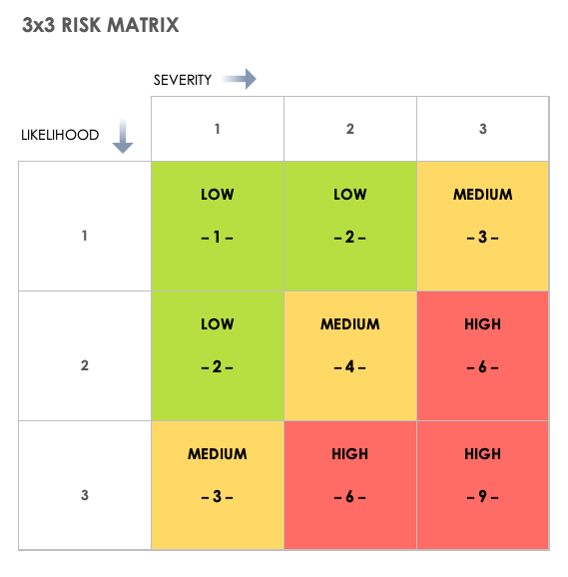

Hazard  Potential harm and how caused | Persons likely to be affected | Existing control measures | Risk Rating before further measures | Further action required or ongoing measures to control risk | Risk Rating after measures | Corrective Action
Hazard  Potential harm and how caused | Persons likely to be affected | Existing control measures | Likelihood x severity | Further action required or ongoing measures to control risk | Likelihood x severity | Who | When | Done
Falling into pond from boardwalk  - Low  - Slippery surface, impulsive behaviour | School Children | - Safety briefing before entering pond area  - Avoid area with children known to be impulsive around water  - Grip material on boardwalk  - Limited number of children on boardwalk at any time | 1L  1S
Tripping on the slabs at water garden  - Low to Moderate  - Slippery surface, unsafe behaviour | School Children | - Inspecting ice which makes it slippery, when sub-zero temperatures  - Prevent running in the area through instruction  - Stop activity if unsafe | 1L  2S
Trapped fingers in toilet block door  - Low to Moderate | School Children | - Supervised entry and exit of toilet block  - One out, one in | 1L  1S
Nettle stings and thorn scratches  - Low  - Children unaware of stinging plants | School Children | - Warn of risk of being stung  - Avoid areas when necessary | 1L  1S
Hay fever attacks  - Low  - Unavoidable | Everyone | - Advise of seasonal pollen risk in pre visit comms | 1L  1S
Tick bites  - Low/Moderate  - Walking through areas with high prevalence of ticks | Everyone | - Avoid areas where high densities are known  - Advise to wear long sleeves and trousers  - Check for ticks on body after walking through long grass | 1L  1S
Injury from falling out of a tree  - Severe, broken bones  - Unsafe behaviour or slipping | School Children | - Avoid climbing on unsafe trees  - Supervise tree climbing- set max height according to ability/age of children  - Stop/prevent activity if behaviour is deemed unsafe | 1L  2S
Injury from moving large sticks or logs  - Low to Severe  - Unsafe behaviour and lack of special awarenness | Everyone | - Instruct on safe lifting and moving before activity  - Don’t lift anything too heavy without help from others  - Be aware of who is around you at all times  - Call out warnings if moving logs, to make others aware  - Do not throw sticks, logs or pieces of wood | 1L  1S
Injury from falling off of fire circle logs  - Low to Moderate, twisted ankle, bumps  - Unsafe behavior, slippery surfaces | School Children | - Staff will intervene if behaviour is likely to cause injury  - Prevent children walking on logs if slippery and wet | 2L  1S
Bacteria soil and composts – in wounds or ingested  - Moderate/Severe  - Contact with open wounds | School Children | - Keep open wounds covered with an adhesive dressing/plaster  - Wear garden gloves when working with soil and compost  - Wash hands after handling  - Use hand sanitizer if soap and warm water not available | 1L  2S
Ingestion of non-edible plants  - Moderate/Severe  - Negligence or lack of knowledge | School Children | - Intro talk from staff member when entering kitchen garden  - Only encourage eating plants if part of a planned activity  - Weed out any toxic, non-edible plants from kitchen garden  - Only encourage eating plants if part of a planned activity  - Point out edible plants and plants to avoid before starting any activity  - Discourage ingestion of any plants until it has been checked by knowledgeable staff | 1L  2S
Burns and Scalds from small fires  - Moderate/Severe  - Negligence or tripping/slipping | School Children | - Behaviour and activity parameters set before children allowed near fire  - Maximal adult supervision around fires  - No running inside the fire circle  - Fires in woks to be kept very small  - Plunge water buckets on hand  - Put fire out immediately after use  - Children only approach fire if told to  - Earth Trust staff/volunteer handles all cooking on the open fire | 1L  2S
Burns and Scalds from Wood Fired Oven  - Moderate/Severe  - Accidently burns from shifting logs, hot coals or hot surfaces | Everyone | - No children are allowed within 2m of the lit oven  - No movement behind the oven when it’s lit  - One Earth Trust staff member operates the wood fired oven at any time  - No one touch the outside of the oven when in operation  - Close the oven door when finished using – never use water  - Full length pizza peel used to move wood and food  - Bellows used to clear oven of ash and embers  - Avoid putting hands inside the oven | 1L  2S
Starting wildfire  - Moderate/Severe  - Negligence | Everyone | - Do not light fires under drought conditions  - Monitor wind speed and direction if outdoor temperate over 28C | 1L  2S
Danger from discarded items  - Low to Severe | Everyone | - Check area frequently to prevent contact of items with school children or the public  - Dispose of safely by wearing gloves and using a tool. Do not pick up with hands. | 1L  1S
Weather associated hazards  - Low to Severe | School Children | - Monitor weather conditions/warnings using the MetOffice  - Review annual tree safety survey for dangerous branches  - Wear appropriate clothing and advise other to do the same  - Take appropriate breaks and advise others to do the same  - Ensure children are carrying water bottles in hot temperatures | 1L  1S
Members of public  - Low to Severe | School Children | - Make everyone aware that this is a public access site at beginning of the session  - Conduct regular head counts  - Keep all children in sight at all times | 1L  1S
Lost children  - Severe | School Children | - Conduct regular head counts  - Keep all children in sight at all times  - Stop activity if unsafe | 1L  2S
Cuts and crush injuries  - Moderate to Severe | School Children | - Provide training before tool use  - Wear protective gloves  - Provide training before lifting | 1L  1S
Collisions with Vehicles  - Severe  - Negligence | School Children | - Safety check before crossing the road  - Avoid activity around active farm vehicles | 1L  2S
Falling from stationary tractor step  - Moderate | School Children | - Ask children not to climb on tractor steps | 1L  1S

 | RISK ASSESSMENT | RA No.

Part 3 – Review

Category No: | 1 Regular review | 2 Result of accident | 3 Result of near miss | 4 Change of process | 5 Change of location | 6 Personnel change

Date | Category no | Assessor/s | Comments | Action required | Date closed
28/07/2025 | 1 | Stuart Ritchie

 | RISK ASSESSMENT | RA No.

Part 4 – Record of understanding

To be filled in by all persons responsible for the safety of the relevant task, workplace, event
Date | Name | Signature

