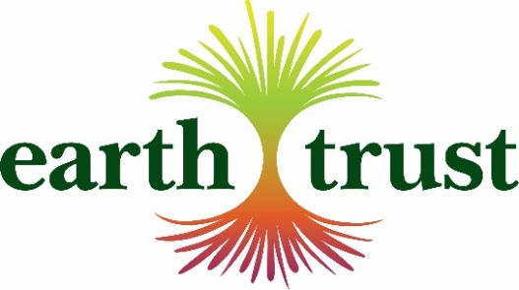

Visitor Research Volunteer

When: Flexible

Where: Earth Trust Centre, Little Wittenham OX14 4QZ or
Community Reserves managed by Earth Trust or local town centres

What does the role involve?
Gathering data and feedback from people, Including our visitors to help us learn more about their experience with the Earth Trust and how we can improve it, as well as their motivations, interests and their awareness of environmental issues and how they like to spend their free time.
- Engaging people in short semi-structured conversations to collect their feedback.
- Recording how many people visit a particular site by doing visitor counts.
- Inputting the information obtained from the research into a spreadsheet.
- Recording any queries.
- Where appropriate, signposting people to information on Earth Trust events and wider programmes.
- Asking people if they would like to subscribe to the Earth Trust e-mailing list.

What attitudes, skills and experience do I need?
- Enjoy communicating with visitors in a relaxed and informal way.
- Ability to communicate face-to-face in an effective and friendly manner.
- Able to record the key points of a conversation clearly and concisely.
- Confident with using Word and Excel.
- Outgoing, approachable and helpful.
- Reliable and trustworthy.

Why Earth Trust needs you:
Experiences that interpret the environment and help people discover more about why and how to protect it are at the heart of what Earth Trust does. We are looking for new and innovative ways to stimulate conversations about the health and welling benefits of nature; food production and farming; ecosystem restoration; and natural resource management by engaging people in green spaces. We need to understand more about our visitors so that we design the best possible experiences for them. Your help in talking to people and recording their feedback will have a direct impact on decisions about what we offer at the Centre, across our green spaces and o our digital channels and how we interpret our work to champion accessible natural green spaces and inspire people to think about their impact on the planet.

What’s in it for you?
This is a great opportunity to develop your communication, research, customer service and organisational skills. You will meet like-minded people and be a member of an enthusiastic and knowledgeable team. You’ll have the satisfaction that you are helping Earth Trust protect and nurture important local green spaces and get to spend time in those beautiful green spaces.

How Earth Trust will support you:
You will be fully supported by the Earth Trust Visitor Experience Manager and will be provided with all the materials you need and Earth Trust volunteer identification. You will be invited to training sessions providing information about the work of the Trust, and the impact it has within the local area.

What do I do next if I want to apply or need more information?
Please contact Nicola Williams, Volunteer Officer – 01865 407792 or Nicola.Williams@earthtrust.org.uk

